**Openfield Proficiency Testing Scheme**

**PORTAL Quick Guide**

1. Using **GOOGLE CHROME…**go to [www.optsportal.openfield.co.uk](http://www.optsportal.openfield.co.uk) log in using your email address and then enter your password
2. Click Submit Results …….then Select a subscription/instrument… Select the id number you are putting results in for
3. Select a scheme, select the commodity you are putting results in for
4. Select a round….. select the month that you are putting results in for
5. Tick the “hide” box of the tests you do NOT wish to report
6. If you hide a test by mistake or all the tests you wish to report are not appearing…………. click “Show All Tests”……..

then “unhide” the tests you wish to add in

then click “back to submit”

This will take you back to the page to input your results

1. Type in the Result………Operators Name……….Instrument (from the drop down box)

(If the instrument you are using is not shown please let me know and I will add it to the list)

(**PLEASE DO NOT LEAVE INSTRUMENT BLANK** as this will not allow us to monitor/colour code the bar charts per instrument type)

**IF YOU ARE PERFORMING REFERENCE TESTS (OVEN or 1L KERN or DUMAS or oil NMR/EXTRACTION**……Please make sure **that** result is the one that is “Nominated”

1. Click “Submit Results” at the bottom of the page
2. CHECK the results are correct on the drop down box, (Amend if necessary)…….If happy, click “Commit”.
3. You will receive an email showing what you have sent
4. Return to (3.) to change the commodity for that id or return to (2.) to select a different id.

**If you have ANY problems at all please call us at Honey Pot Lane on 01476 862728**

**Printing Reports from the Portal**

1. Log into the Portal as you would to enter your OPTS results, making sure you are using Google Chrome.

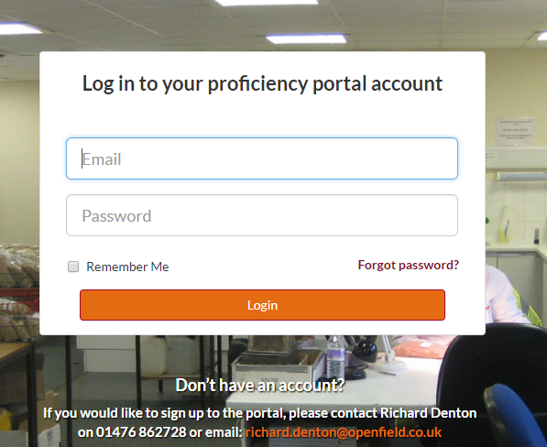

1. 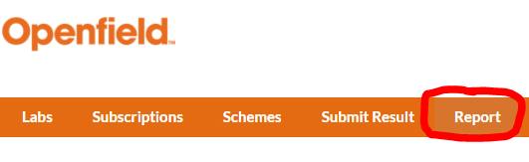Click on the “Report” button in the options bar at the top of the page.
2. 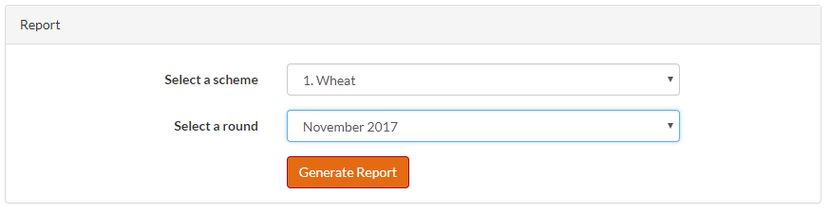From the dropdown options, select the scheme and round you wish to print the report for.
3. Then click on the “Generate Report” button.

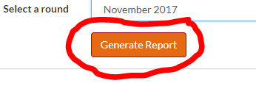

This message will appear to show you it’s working…

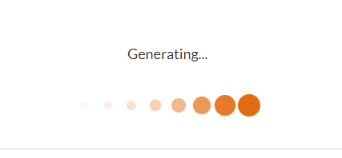

1. All reports for that scheme/commodity will appear and you will be able to scroll through to find your ID number and the graphs at the bottom of the page.

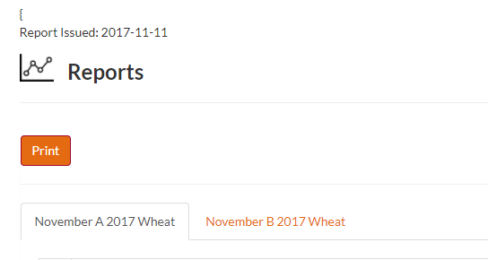

1. To print AND/OR save the reports click the “Print” button.

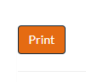

1. The “Print Preview” page will open. If you wish to print a physical copy of the reports, make sure you select to print in colour so you can read the graphs, and double check that the orientation is set to landscape.

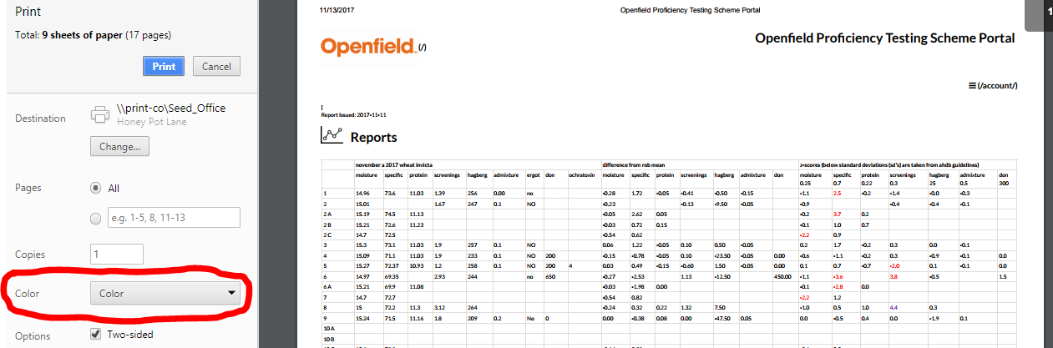

You only need to print once for each scheme, not for each individual report, for example; when you print the reports for wheat you’ll get both Wheat A and Wheat B reports.

1. To save a copy of the reports, click the “Change” button under destination where there is an option to save the document as a PDF file. Click on “Save as PDF”.

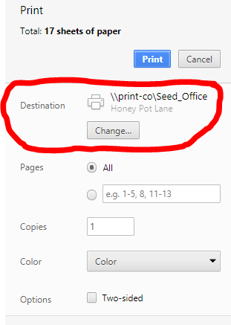

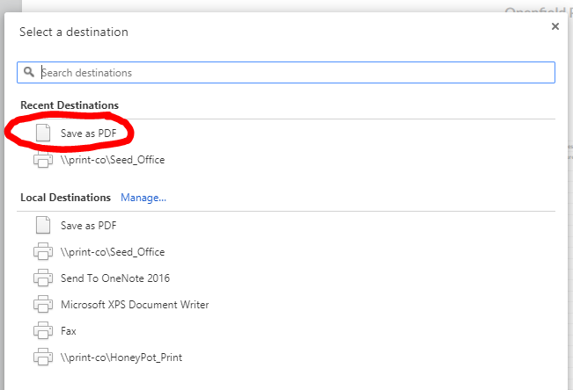

1. You will be taken back the preview screen where you can then click save.

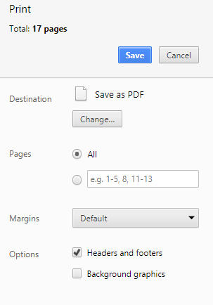

1. Change the file name to OPTS SCHEME ROUND YEAR e.g. “OPTS WHEAT NOV 2017”.

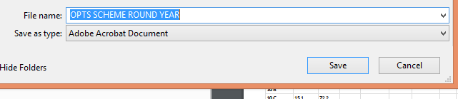

Repeat the process above starting from Step 2 for each scheme/commodity you reported results

**Individual Lab Reports**

We have introduced an “Individual Lab Report” facility on the OPTS portal.

This will allow you to see your results and z-scores for each analyte on an individual Lab ID basis on one small document. (Used in conjunction with the main report and the trend analysis report this can be a very useful report).

To access the “Individual Lab Report” follow the instructions below:-

1. Using Google Chrome, log in to <http://www.optsportal.openfield.co.uk/> as normal.
2. Click “Subscriptions” in the top bar.

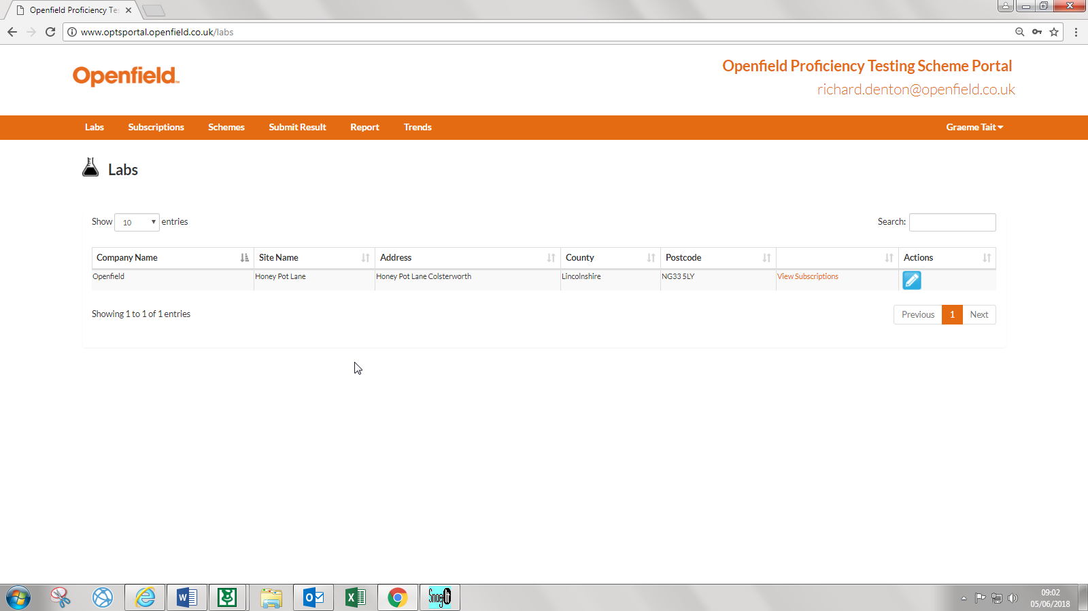

1. Under “Actions” you will see a green button saying “Report”, click it.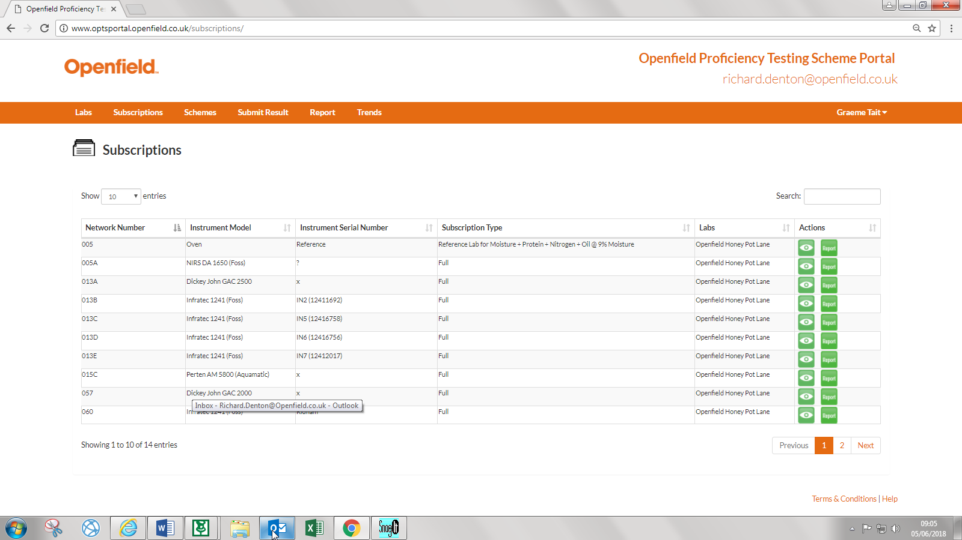
2. You will then see the “Individual Lab Report” for your lab ID.

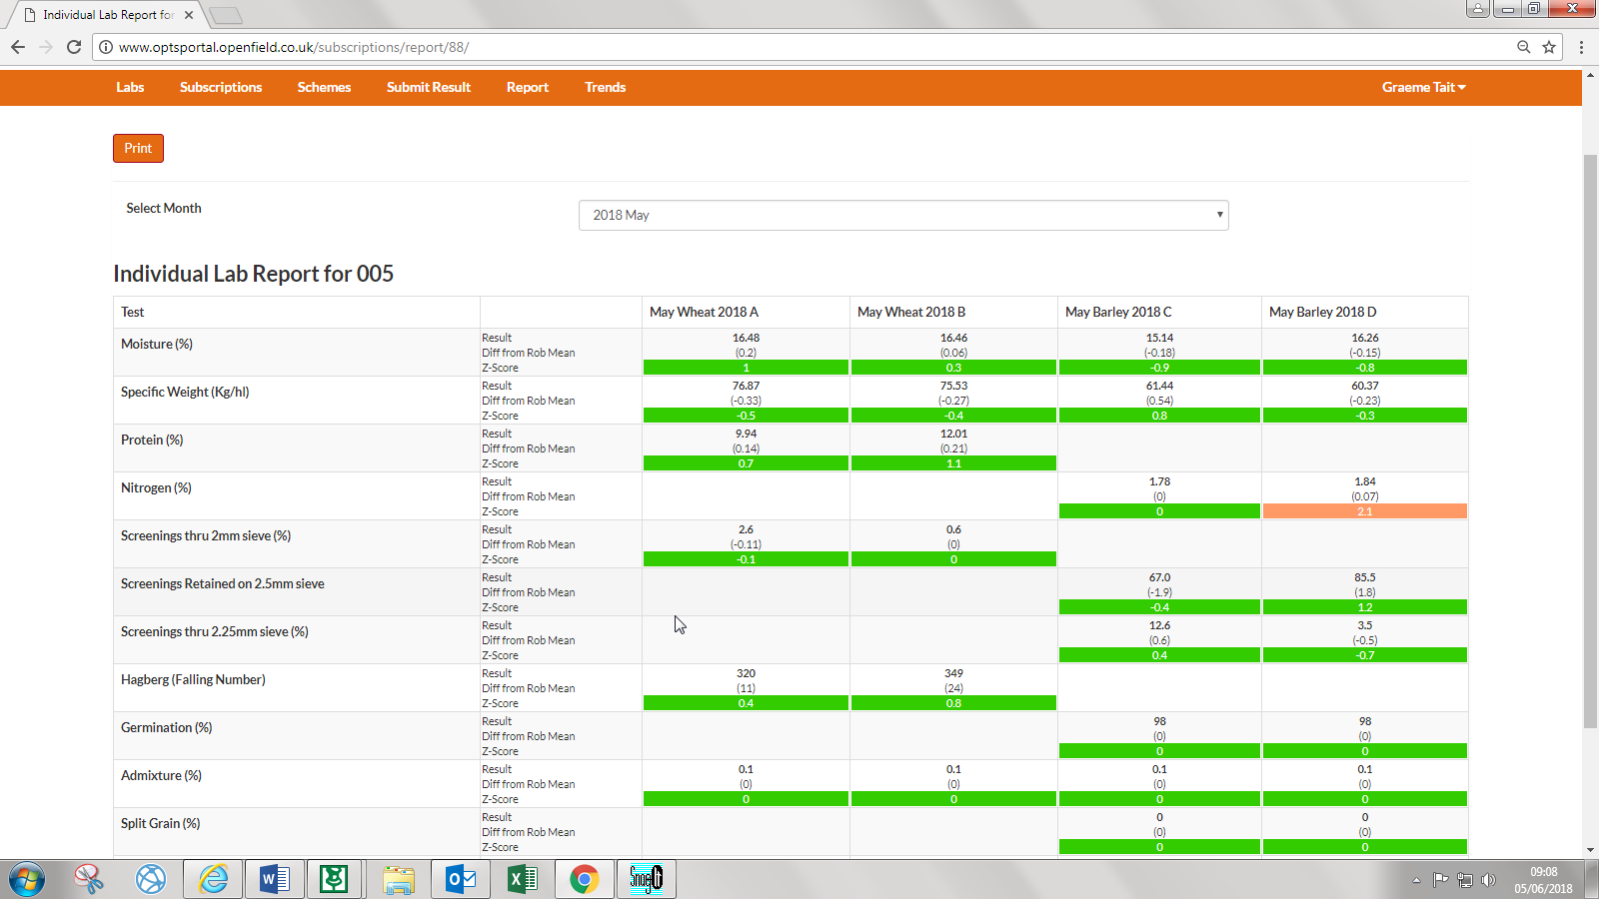

1. You can then “Print” or “Save” this individual report for the month that is named in the “Select Month” dropdown box. (You can also change the month you wish to view by changing it in this box).
2. For those with multiple instruments, if you wish to print or save another instruments “Individual Lab Report”, just click on “Subscriptions” and click the report button next to the instrument that you wish to view.

If you have any problems viewing this report or notice any issues, please do not hesitate to get in touch with us in 01476 862728.

**Z-Score Trend Reports from the OPTS Portal**

**(Make sure you are using “GOOGLE CHROME”**

1. Log in to the Portal as you would to enter your OPTS results, making sure you are using Google Chrome.



1. Click on the “Trends” button in the options bar at the top of the page.

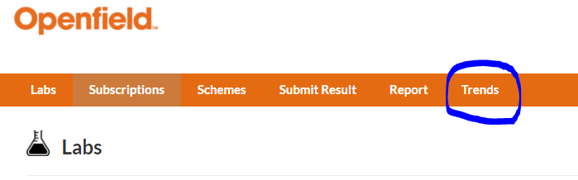

1. From the dropdown options, you have a choice of searching for the report either by selecting a lab or a subscription (Individual instrument).

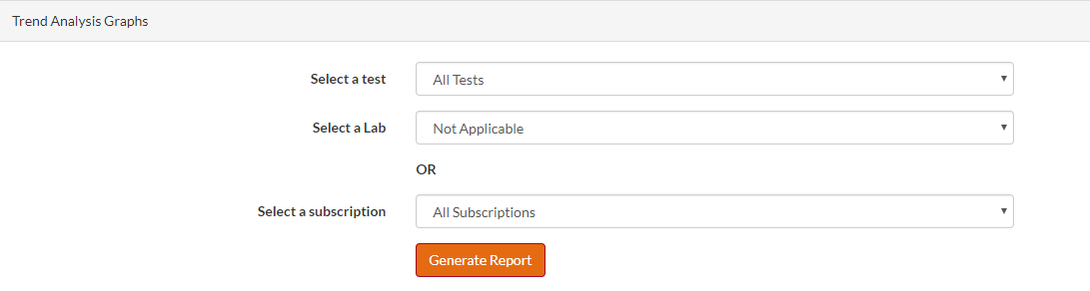

1. To generate the report for your lab (instruments all together), you must select the drop-down option of “select a lab”

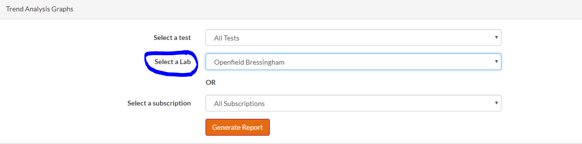

1. Then click on the “Generate Report” button.

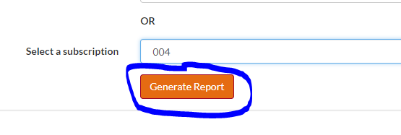

This message will appear to show you it’s working…



1. All reports for that ID number will appear and you will be able to scroll through to see the z-score trend graphs for each test.

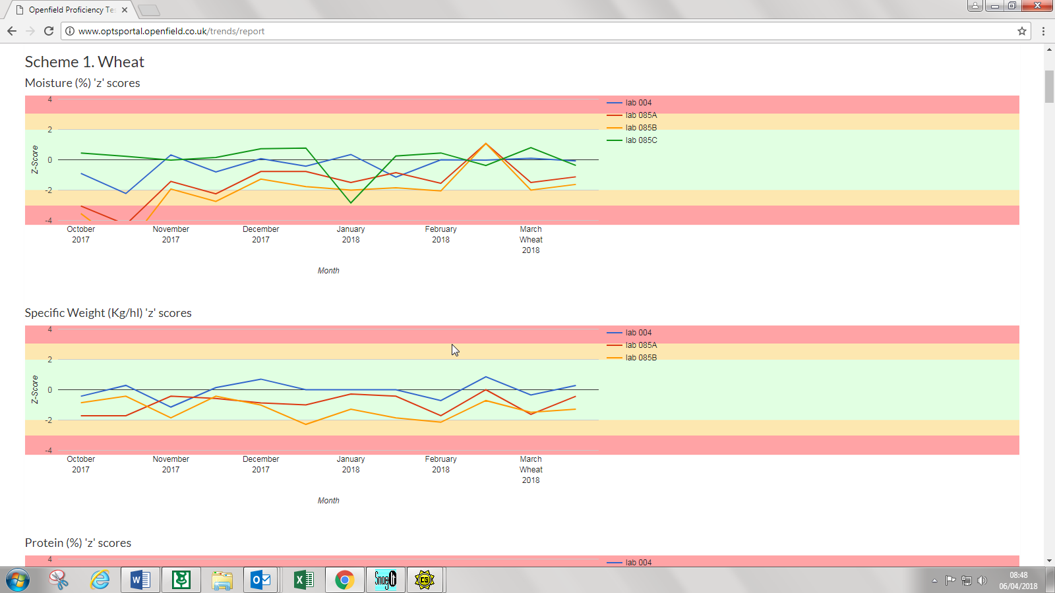

1. To print AND/OR save the reports click the “Print” button.



1. The “Print Preview” page will open. If you wish to print a physical copy of the reports, make sure you select to print in colour so you can read the graphs, and double check that the orientation is set to landscape.

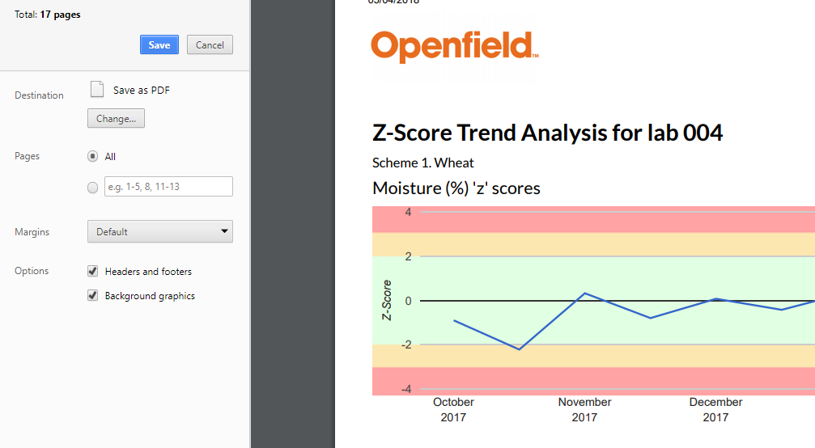

1. To save a copy of the reports, click the “Change” button under destination where there is an option to save the document as a PDF file. Click on “Save as PDF”.





1. You will be taken back the preview screen where you can then click save.

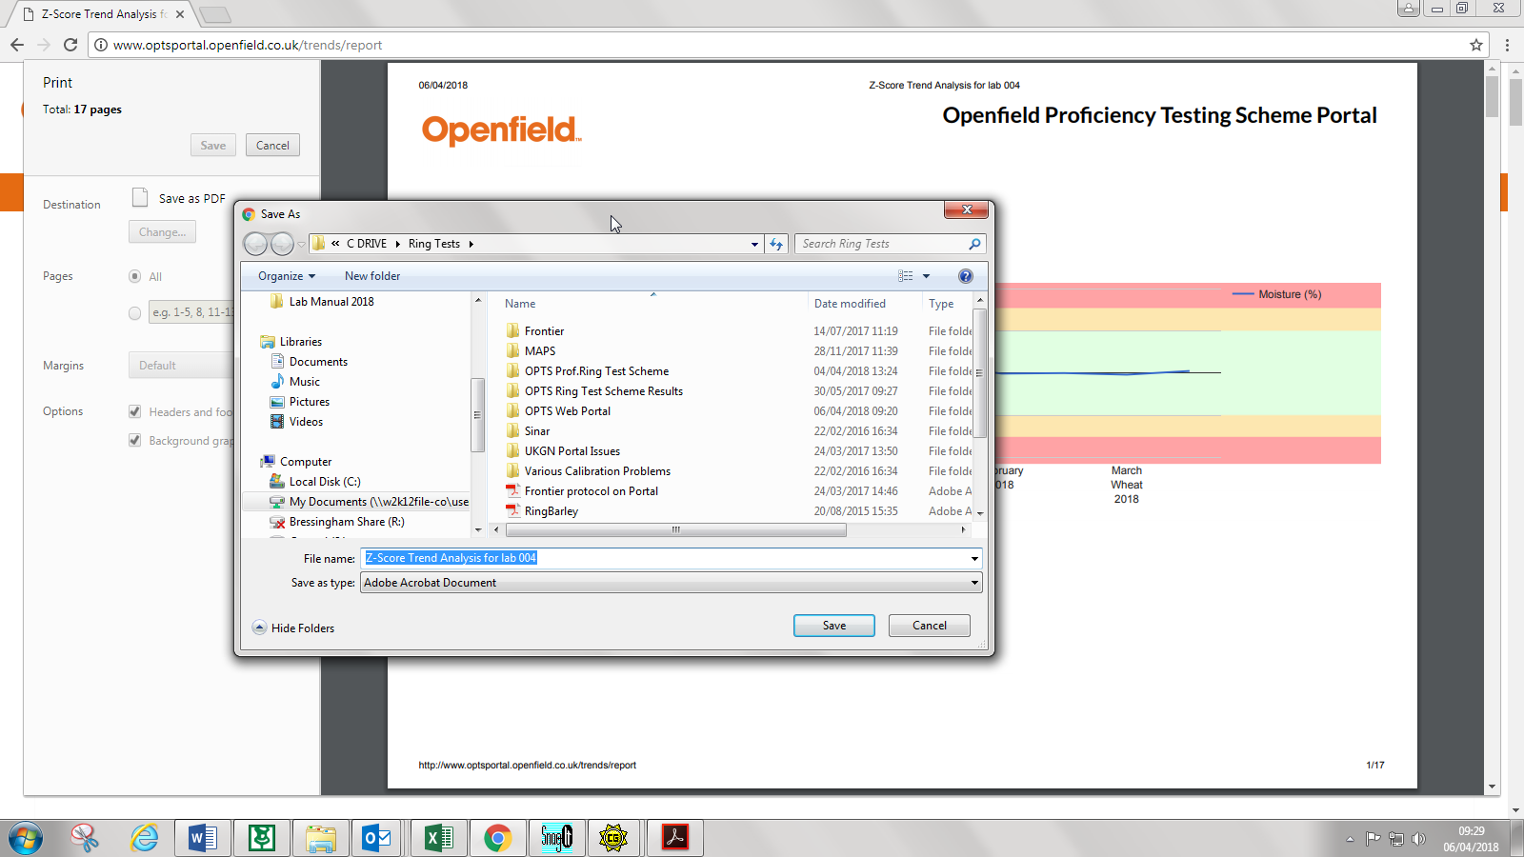

1. Change the file name to “Whatever you want it to say” and wherever you want to save it.

**OR**

1. To generate reports for the instruments individually, please click on the drop-down button of “select a subscription” and choose the appropriate instrument id.

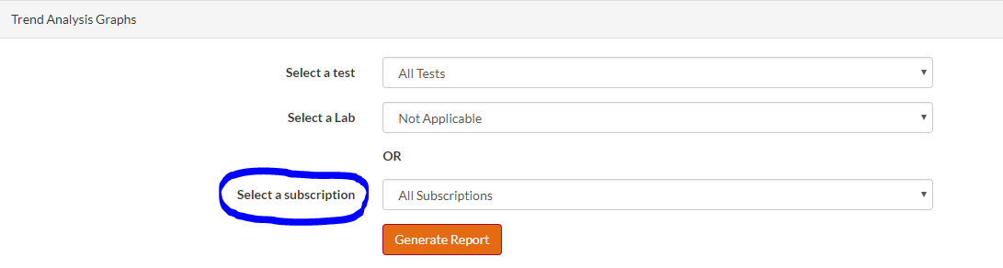

1. You must then choose a subscription ID number.

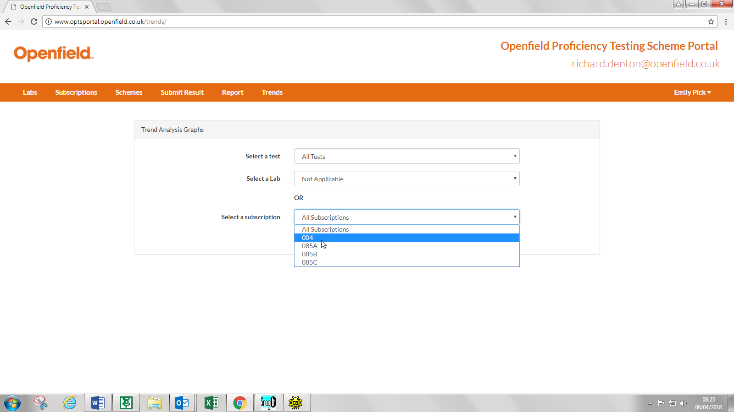

1. You must then click on the “Generate Report” button.

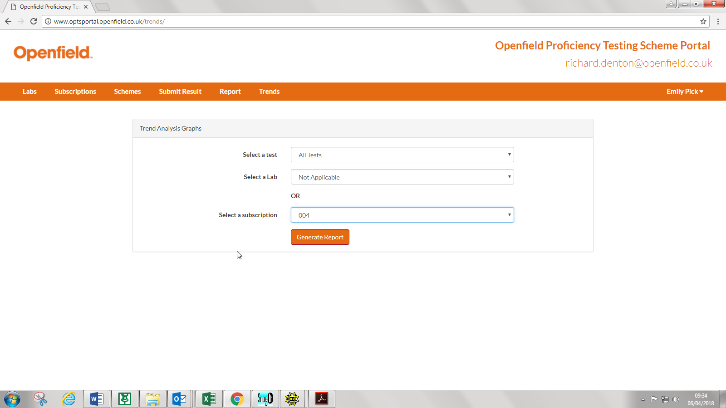

This message will appear to show you it’s working…



1. All reports for that specific test will now appear on the Z Score Trend results graphs and you will be able to scroll through and look at the different commodities for that instrument.

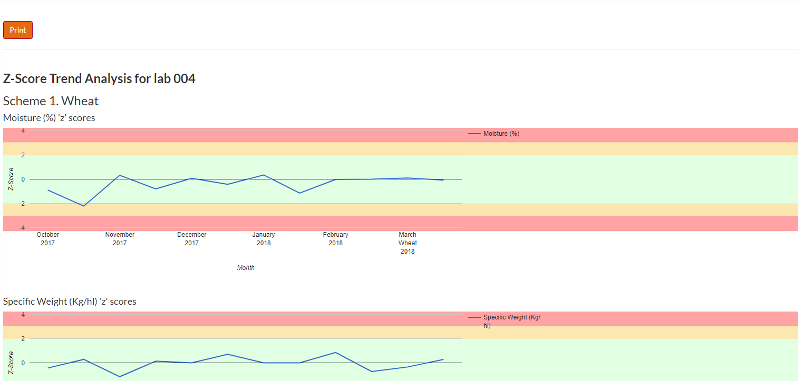

1. Then follow the steps 7 - 11 as before to save and print the Z-score trend graphs.

**Extra**

1. There is another function that you may select if you wanted to just print / save z-score trend graphs for individual tests for your laboratory.

All you do is “click” the drop down button on “Select a Test” and select the particular test.

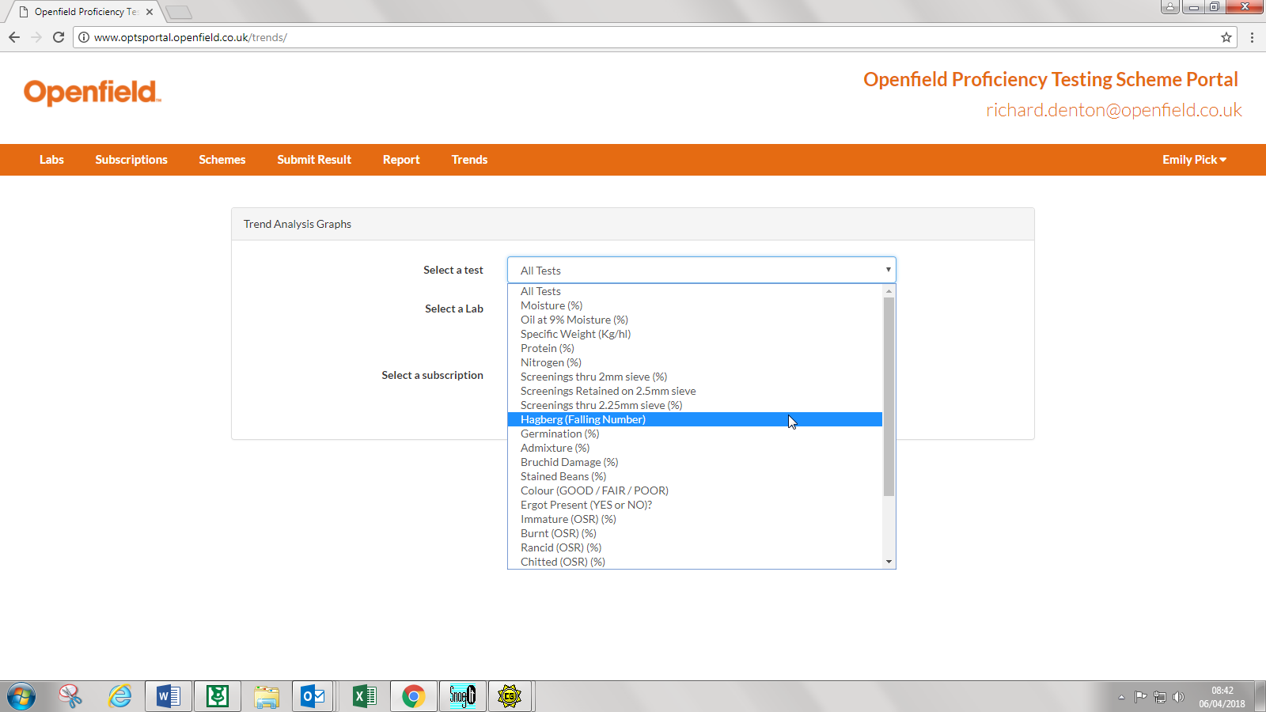

1. Then, either “select a lab” OR “select a subscription” and generate that particular report as above.